IEEE 802.3 standard for LAN (Ethernet)
Introduction
Ethernet is a frame-based computer networking technology for local area networks (LANs). The name comes from the physical concept of ether. It defines wiring and signaling for the physical layer, and frame formats and protocols for the media access control (MAC)/data link layer of the OSI model. Ethernet is mostly standardized as IEEEs 802.3.

History
Ethernet was originally developed in mid 1970s, as one of the many pioneering projects at Xerox PARC. Digital Equipment Corporation and Intel Corporation joined Xerox to define a 10 Mbps Ethernet standard in 1978. Later 100 Mbps version (Fast Ethernet) & 1000 Mbps version (Gigabit Ethernet) came into existence. In 1983, the specification was formalized by the IEEE as the 802.3 specification. At first, the technology only used coaxial cable in a bus topology, however it has changed with the times to take into advantage of new technologies such as twisted pair cabling (10 Base-T), fiber optics (10 Base-FL), and 100 Mbps operation (100 Base-X or Fast Ethernet). The current standard is known as IEEE 802.3u.

Ethernet Cabling
Ethernet has several different variations, each of which uses different cable types, topologies, and distance limitations. However, all variations use the same CSMA/CD protocol. The different types are:
Name | Media Type | Max. Segment Length | Max. Nodes/Segment
10Base5 | Thick coaxial | 500 meters | 100
10Base2 | RG58 (thin) coaxial | 185 meters | 30
10BaseT | UTP | 100 meters | 1024
10BaseF (FOIRL) | Fiber-optic | 2,000 meters | 1024k
1. 10 Base-5 (Thick Ethernet)
This is the original version of Ethernet. It consists of a coaxial cable about 10mm (0.4") thick with transceivers connecting the individual devices on the network to the cable. It allows up to 255 physical connections to a cable segment, and an overall cable length of 500 meters (1650 feet).
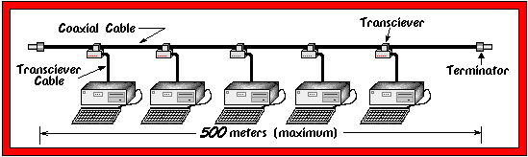

2. 10 Base-2 (Thin Ethernet)
This is the second variation of Ethernet. Here, we dispense with the external transceivers and simply daisy-chain all of the devices on the network together with a thinner version of the cable used in 10 Base-5. Each device on the network is connected to the bus through a BNC "T" adapter, and each end of the bus must have a 50 Ohm terminator attached. Each node on the bus must be a minimum of 0.5 meters (1.5 feet) apart, and the overall length of the bus must be less than 185 meters (606 feet).
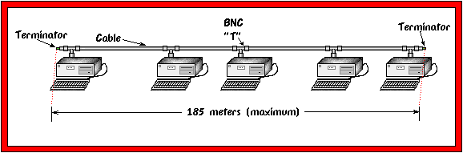

3. 10 Base-T
This is the most popular version of Ethernet. It uses Unshielded Twisted Pair (UTP) cable. Each device has its own cable run of up to 100 meters (330 feet) back to a common hub.
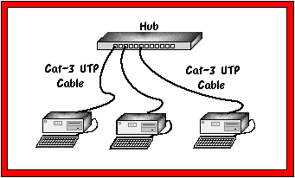

4. 10 Base-FL
This is basically a version of Ethernet which runs over fiber optic cable. It is set up in much the same manner as 10 Base-T, except that it uses fiber optic cable. This allows it to support very long distances of up to 2000 meters (6600 feet) per run. 10 Base-FL is wired in a star topology with all of the fiber optic runs originating from a central hub. It is also acceptable to connect a pair of 10 Base-FL devices directly together with a point to point link.

FRAME FORMAT
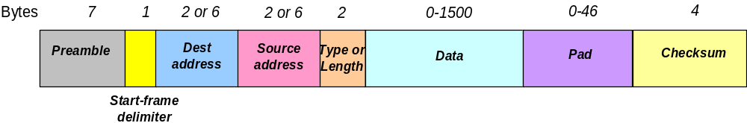
The Preamble consists of seven bytes all of the form 10101010, and is used by the receiver to allow it to establish bit synchronisation (there is no clocking information on the Ether when nothing is being sent).
The Start frame delimiter is a single byte, 10101011, which is a frame flag, indicating the start of a frame.
The MAC addresses used in 802.3 are always 48 bits (6 bytes) long, although older versions of Ethernet used 16 bits. The high-order bit of the destination address is a 0 for ordinary address and 1 for group addresses. Group addresses allow multiple stations to listen to a single address. The address consisting of all 1 bits is reserved for broadcast.
The Length/Ether Type field is the only one which differs between 802.3 and Ethernet II. The Type field tells the receiver what to do with the frame. It specifies which process to give the frame to.
Frames must be at least 64 bytes long, not including the preamble, so, if the data field is shorter than 46 bytes, it must be compensated by the Pad field. The reason for specifying a minimum length lies with the collision-detect mechanism. In CSMA/CD a station must never be allowed to believe it has transmitted a frame successfully if that frame has, in fact, experienced a collision. In the worst case it takes twice the maximum propagation delay across the network before a station can be sure that a transmission has been successful. If a station sends a really short frame, it may actually finish sending and release the Ether without realising that a collision has occurred. The 802.3 design rules specify an upper limit on the maximum propagation delay in any Ethernet installation, and the minimum frame size is set to be more than twice this figure (64 bytes takes 51.2μs to send at 10Mbps).
The Checksum field uses a CRC-32 polynomial code.

Transmission Algorithm
Ethernet uses 1-persistent carrier sense multiple access with collision detection (CSMA/CD) for channel allocation.
When one station wants to send some information, it obeys the following algorithm:
Step 1: Start - If the wire is idle, starts transmitting, else go to step 4
Step 2: Transmitting - If detecting a collision, continue transmitting until the minimum packet time is reached (to ensure that all other transmitters and receivers detect the collision) then go to step 4.
Step 3: End successful transmission - Report success to higher network layers; exit transmit mode.
Step 4: Wire is busy - Wait until wire becomes idle
Step 5: Wire just became idle - Wait a random time, then go to step 1, unless maximum number of transmission attempts has been exceeded
Step 6: Maximum number of transmission attempt exceeded - Report failure to higher network layers; exit transmit mode.

Manchester Encoding
Ethernet uses Manchester Encoding to encode the clock and data of a synchronous bit stream. In the Manchester encoding, logic 0 is indicated by a 0 to 1 transition at the centre of the bit and logic 1 is indicated by a 1 to 0 transition at the centre of the bit. The signal transitions do not always occur at the ‘bit boundaries’ (the division between one bit and another), but that there is always a transition at the centre of each bit. The Manchester encoding rules are summarized below:
Original Data | Value Sent
Logic 0 | 0 to 1 (upward transition at bit centre)
Logic 1 | 1 to 0 (downward transition at bit centre)

